Booting Procedure of RHEL7/8 and Troubleshooting
Tasks
1.Reboot your CentOS 7 or RHEL 8 virtual machine and, during startup, press the appropriate key to access the GRUB2 boot menu; take a screenshot of the GRUB menu screen.
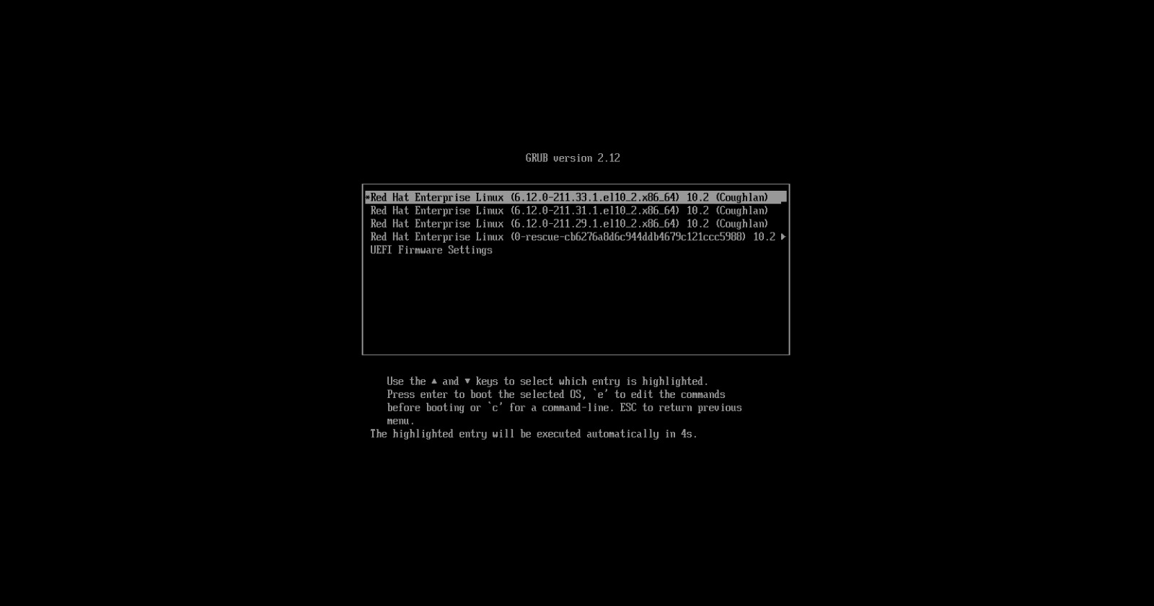

2.Use the 'journalctl -b' command to view the system logs from the current boot and identify the timestamp when the multi-user.target was reached.Hint:</strong> Search for 'Reached target Multi-User System' in the output.

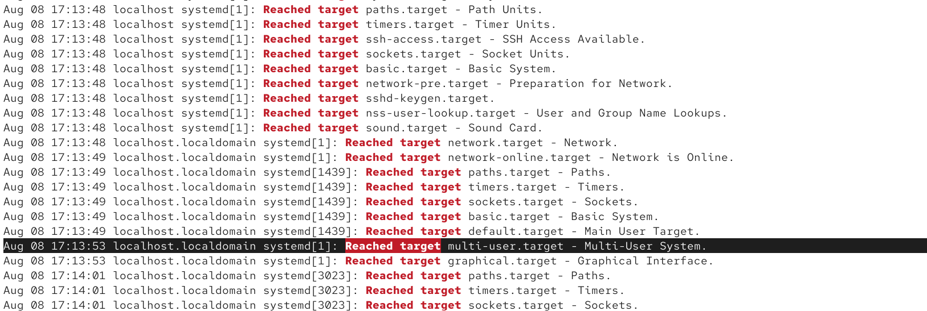
3.Simulate a boot failure by editing the /etc/fstab file and adding a fake mount entry, then reboot your VM and document the error message that appears during boot.Constraint:Restore your original /etc/fstab after testing to avoid permanent boot issues.

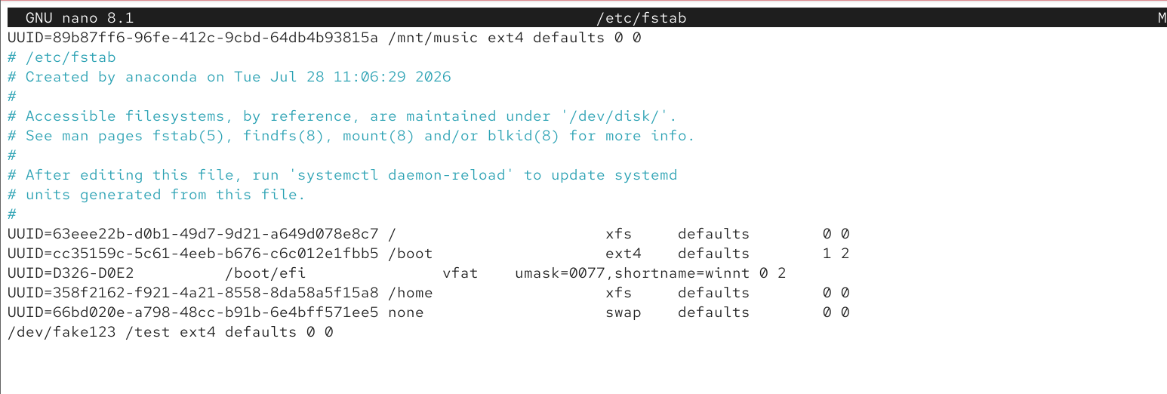
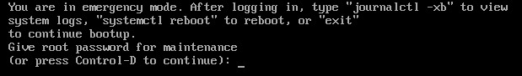

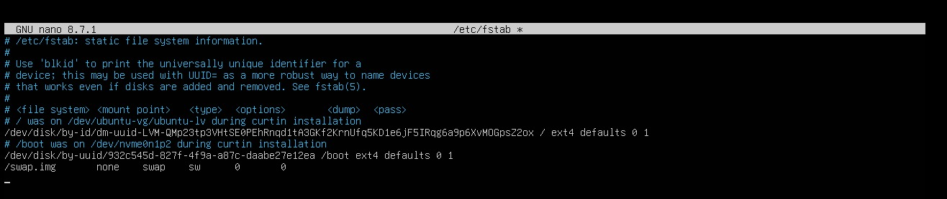
4.Use the 'systemctl list-units --failed' command after booting to identify any failed services, and write down the name of one failed service and the command you would use to check its status.

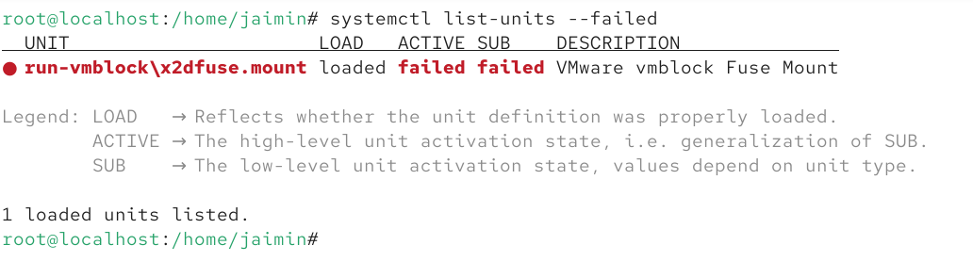
Failed Service name: run-vmblock\x2dfuse.mount

Command to check status:
systemctl status run-vmblock\x2dfuse.mount

5.Suppose your system is stuck at the emergency shell prompt during boot. Use ChatGPT to generate a step-by-step recovery plan for this scenario, then try following those steps on your VM and note any differences or extra steps you had to take.
Step 1: Boot into Emergency Mode
Restart the VM.
If there is an invalid /etc/fstab entry, the system will stop and display the Emergency Mode prompt.
Enter the root password to log in.

Step 2: Remount the Root Filesystem
The root filesystem is mounted as read-only, so make it writable:
mount -o remount,rw /

Step 3: Check the /etc/fstab File
Open the file:
nano /etc/fstab
Find the incorrect or fake entry.
Example of a bad entry:
/dev/fakepartition /mnt/fake ext4 defaults 0 0

Step 4: Fix the File
Remove or comment the bad line
#/dev/fakepartition /mnt/fake ext4 defaults 0 0
Save the file.
Press Ctrl + O
Press Enter
Press Ctrl + X
Step 5: Verify the Configuration
Run:
mount -a
If no errors appear, the file is correct.
If errors appear, edit /etc/fstab again and fix them.

Step 6: Reboot the System
reboot
The system should now boot normally.

